Use Case Diagram : We all know Its a Behavior Model and Its the Relation between user aka ( as known as) Primary ACTOR and Administrator aka Secondary Actor.

One of the most useful Diagram in Software Engineering.

We will take One Scenario i.e. "Report Card Management"

1. Students aka Primary Actor, have to register first through fill up the registration form.

2. Faculty (Secondary Actor) can prepare the grade sheet of concern subjects.

3. Student and faculty can see the result of each student.

4. Faculty can generate the report about registered students.

5. System Admin (Secondary Actor) can verify the students Registration Details First.

6. Student may have to fill up the hostel details during registration process.

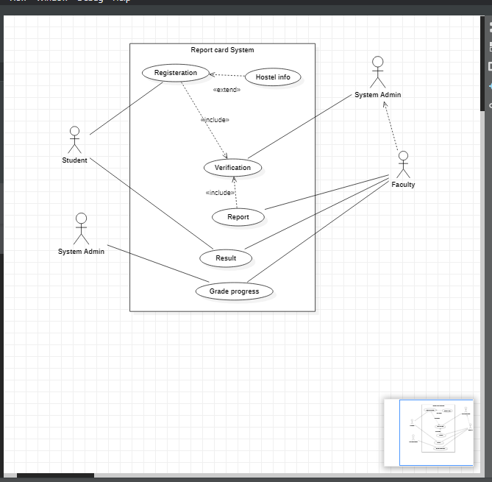

Note =>

Also, there can be many cases for the same scenario. It depends on you how you think to make it

More functional.

We can set the use case to check grades of specific subject for students aka (Primary Actor).

a